Assignments 2 ADTA 5560 Recurrent Neural Networks for Sequence Data

Yog Chaudhary
11727095
ADTA 5560 Recurrent Neural Networks for Sequence Data
Professor: Dr. Thuan L Nguyen
University of North Texas Sep 29, 2024

2. PART I: Biological Neural Network & Artificial Neural Network (30 Points)
  - The human biological Neural network:
The human biological neural network, made up of many billions of neurons that work in concert to process information, enables sensory perception and control of bodily functions. More commonly known as the nervous system. It is the most complex structure in the known universe. It is responsible for all our actions: thinking, feeling, moving, and sensing our environment.

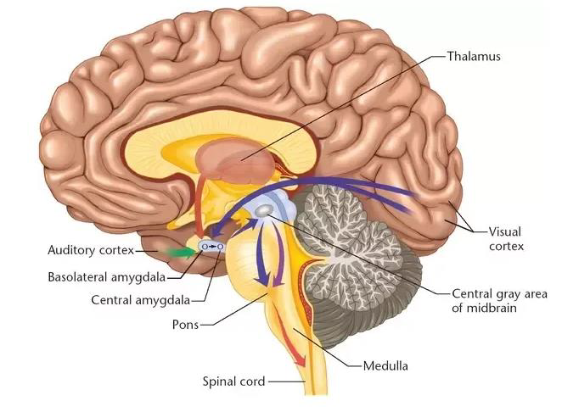

Here's a breakdown of its key components and how they work together:
- Neurons:
- The basic components of the neuron system
- Estimated 100 billion neurons in the human brain alone.
- Each neuron has a cell body, dendrites (which receive signals), and an axon (which sends signals).

Human Neuron (Source: by Bruce Blaus, is licensed under CC BY 3.0)

- Synapses:
- The Synapses are gaps in which neurons communicate. Neurons are allowed to interconnect and develop complicated networks.
- The Synapses helps integrate sensory, chemical messengers called neurotransmitters bridge the gap between neurons.
- Bonds can vary in strength, so that support may change over time, permitting learning and memory.

- Actions potential:
- Neurons generate action potential to communicate information throughout the body.
- Nerve impulses that travel along a neuron's axon.
- Initiated by the summation of the input signals received at the dendrites.
- Follow an all-or-nothing principle: the signal either reaches the threshold and fires or does not.

- Nervous system organization:
- The CNS includes the brain and spinal cord, which receive and process sensory information, producing thoughts and sending out motor commands while coordinating reflexes and communication throughout the body.
- The Peripheral Nervous System (PNS) consists of all the neurons outside the CNS, controlling voluntary movements through the somatic system and involuntary functions through the autonomic system.
- Autonomic nervous system (controls involuntary functions like heart rate and digestion).
- Neurons transmit electrical signals called action potentials through synapses, forming neural networks. Sensory information is gathered by neurons in the PNS, processed in the CNS, and responses are generated. Local and inter-regional circuits coordinate movement, sensation, and complex behaviors across the entire brain-body system.
In conclusion, neurons, synapses, and action potentials all work in coordination within the nervous system, allowing communication between the brain and body. Processing sensory information, generating responses, and controlling both voluntary and involuntary functions all rely on the CNS and PNS working together. It is through such coordination that learning, movement, sensation, and, in general, body functions and regulation are effected properly.

1.2 The McCulloch-Pitt neuron model:

The McCulloch-Pitts neuron model is a mathematical model of a biological neuron using inputs, weights, and a threshold activation function those outputs in binary. Basic modeling of biological neurons and logical operations forms the foundation for artificial neural networks.

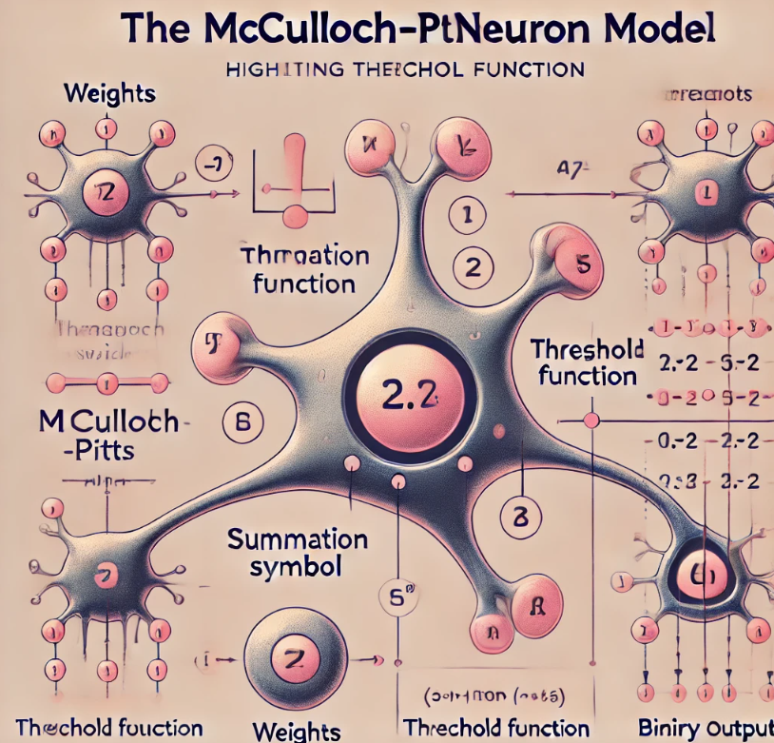

The following several diagrams are extension of inputs, weights, summation symbol Σ, threshold function and the binary output with main concept of activation threshold.

McCulloch-Pitts Neuron McCulloch-Pitts neuron is a mathematical model and basis for a biological neuron's functioning, developed in 1943 by Warren McCulloch and Walter Pitts.

Here's a breakdown of its structure and function as following.

Structure
- Inputs: Gets several binary inputs, either 0 or 1, representing signals from other neurons.
- Weights: Every input has a corresponding weight, which represents its effect on the ultimate output.
- Summation Functions: Signals coming in are multiplied by their weights and added up.
- Threshold Function: The summed value gets compared to a given threshold. When the values cross the threshold, the neuron gets activated; otherwise, it remains inactivated.
- Outputs: The binary output (1 or 0) representing the decision of the neuron in its most basic form.
Function:
- Each input has one value bound to it, 0 or 1, and it is multiplied by the weight.
- All these weighted values are summed.
- The neuron "fires"-producing an output value of 1-if the sum is greater than a threshold set.
- If this sum is less than that threshold, the neuron fires; otherwise, it does not fire, outputting 0.
Think of it as a simple decision-making unit:
- Assume inputs of environmental factors such as temperature and humidity.
- Weights indicate the relative importance of each factor in an insect's survival.
- The threshold is the minimum safe aggregate value.
- If the weighted sum is greater than the threshold (danger detected), the insect decides to find shelter (output = 1).

Limitations:
- Binary inputs and outputs restrict the model's complexity.
- It cannot learn or adapt, limiting real-world applications.

Importance
- The McCulloch-Pitts model, though suffering from various deficiencies, marked the beginning of modern neural network architecture.
- It motivated work in artificial intelligence and machine learning by showing how computational models could mimic aspects of neural processing.

Key Takeaways:
- The McCulloch-Pitts neuron model, though simple, was an important step towards understanding how neurons might compute information.
- Unlike its competitors, it formed a basis for further neural network developments.
- It is a forerunner of research in far more complex and powerful models of artificial intelligence.

  - The pioneers in the AI field:

The pioneers in AI include those mathematicians and researchers who have created basic theories, algorithms, and models of simulating human intelligence, furthering the understanding of the brain in learning, reasoning, and problem-solving, which form the basis of modern neural networks and machine learning.

The development of artificial neural networks was inspired by the ability of the human brain to process information, learn, and adapt. The pioneers in artificial intelligence, like Warren McCulloch, Walter Pitts, Frank Rosenblatt, John McCarthy, Marvin Minsky, and others, were working on replicating the functioning of biological neurons to create machines that could think and learn.

McCulloch-Pitts Neuron Model, 1943: Drawing inspiration from the way real neurons function, it's the foundation of artificial neural networks. Imagine simple joined circles, each receiving signals and providing some output. These 'artificial neurons' imitated the basic structure and function of real brain cells.

1949: Hebbian Learning: Donald Hebb hypothesized that the connections between neurons strengthen with use. This idea, Hebbian Learning, became central in designing networks that learn and adapt from experience.
1957: Perceptron. Frank Rosenblatt developed the first true neural network, an event of enormous importance for the development of AI. Imagine several layers of interconnected McCulloch-Pitts neurons, inspired by the design of the brain. Thus, the Perceptron was able to learn and recognize elementary patterns by adjusting the strength of its connections, imitating a brain learning process.

Key Inspirations from the Brain:
- Interconnected Neurons: Neural networks mirror the brain's structure, with interconnected processing units communicating through weighted connections.
- Learning and Adaptation: Inspired by Hebbian learning, early networks adjusted connections based on experience, mimicking the brain's learning process.
- Parallel Processing: Neural networks, like the brain, distribute computations across many units, thereby speeding up computation and increasing efficiency.
Advances and Challenges:
- Limitations: Early models like Perceptron struggled with complex tasks and lacked the brain's full complexity.
- Training Difficulties: Training these models requires significant resources and specific data formats.
Despite such challenges, pioneers achieving, thereby leading to breakthroughs in artificial intelligence and neural network development.
Challenges and Advancements:
- Limitations: Early models, like the Perceptron, struggled with complex tasks and did not capture the full complexity of the brain.
- Training Difficulties: Training these models requires significant resources and specific data formats.
Despite these problems, the pioneers persisted, and the breakthroughs followed.
1974: Backpropagation Algorithm: Paul Werbos will introduce a revolutionary way of training complex networks, where image errors move backward through a network, adjusting connection strengths to improve future performance—in the brain, learning from feedback.
1982: Hopfield Network: John Hopfield introduced a recurrent neural network, inspired by the brain and its associative memory. Imagine the network storing and retrieving patterns—just like we remember associations in our memories.
Legacy and the Future:
Though not exact duplicates of the brain, early models did provide a template for the much more sophisticated deep-learning systems, like CNNs and RNNs, now employed in image recognition, language translation, and self-driving cars.
The journey continues as the researcher explores neuroscience with the purpose of creating advanced AI systems inspired by biology. Though we may never create an exact replica, early pioneers inspire ever-more intelligent machines.
3. PART II: Linear Algebra for Deep Learning: Matrices (25 Points)

We have given me Matrix Multiplication solution.

5, 3, 8
A = B = ?
2, - 1, 7

We have determined Matrix B, So that Multiplication Matrix A * B
Step 1: Define Matric B

We have here Matric A is 2 * 3 for define matrix B should be a 3 * n, where n can be any number greater than or equal to 1. We will assume n = 2

1, 0
B = -2, 3
4, -1

Step 2, Compute C = A * B
Salutation, C, we need to perform the Matric between A and B

5, 3, 8 1, 0
A * B = 2, -1, 7 * -2, 3
4, -1

We have Calculated Each element of C:

Taking the 1’st row of A and 1’st Column B and multiple elements, the sum the results
C11 = (5×1)+(3×−2)+(8×4)=5−6+32 = 31

Taking the 1’st row of A and 2’nd Column B and multiple elements, the sum the results
C12 = (5×0)+(3×3)+(8×−1)=0+9−8 = 1

Taking the 2’nd row of A and1’st Column B and multiple elements, the sum the results
C 21 = (2×1)+(−1×−2)+(7×4)=2+2+28 = 32

Taking the 2’nd row of A and 2’ndColumn B and multiple elements, the sum the results
C 22= (2×0)+(−1×3)+(7×−1)=0−3−7 = −10

Matric the Results C Is:

31, 1
C =
32, -10

Steps 3: Dimensions of Metric C
Matrix A is 2 * 3 , and Matrix B is 3 * 2, Therefor, the resulting matric C has dimension:
C : 2 * 2

Step 4: Explanation of the Dot Product C = A * B

The dot product of the two matrices is described by taking each row from the first matrix and each column from the second matrix, multiplying corresponding elements, and summing it up. This is then placed in the corresponding position in the resulting matrix. Matrix multiplication can only be possible if the number of columns in the first matrix equals the number of rows in the second matrix.

Now, in the given problem, every element of will be determined as the sum of products between elements of the corresponding row taken from matrix A and the column from matrix B. The resultant matrix C will give value for each row-column combination of the given matrices A and B.
Summary Results:

Matrix B:
1, 0
B = -2, 3
4, -1

Matrix of C = A * B

31, 1
C =
32, -10

Dimension of C : 2 * 2
Explanation: The dot product involves multiplying rows of A by columns of B, summing the product of corresponding elements.

4. PART III: Linear Algebra for Deep Learning: Matrices (45 Points

Question 3.1: Let’s consider this matrix as a vector of vectors.
How many vector elements does this matrix have, along Axis 1?
Show each vector element, one by one.

Solution,
We know that given the following matrix as a 2D array:

2 1 3 4 5
0 0 1 4 2
4 2 6 8 10
6 3 14 35 33

When considering the matrix as a vector of vectors along Axis 1, each row is a vector. Therefore, this matrix has 4 vector elements along Axis 1, corresponding to each row.

- { 2, 1, 3, 4,5 }
- { 0,0,1,4,2 }
- { 4, 2, 6, 8, 10 }
- { 6, 3, 14, 35, 33}

Question 3.2: Add 3 to Vector Element at Index 1:

We have added 3 to each element of the vector at index 1, which is the second row [0,0,1,4,2]. Adding 3 element-wise gives:
[0+3, 0+3, 1+3, 4+3, 2+3] = [3, 3, 4, 7, 5]

After that Operations, the update Matrix is :

2 1 3 4 5
3 3 4 7 5 Update matrix
4 2 6 8 10
6 3 14 35 33

Question 3.3: Flatten the Matrix

To flatten the matrix means converting it to a single 1D array, with all elements in sequence are follows:

Flattened version of the updated matrix: [2, 1, 3, 4, 5, 3, 3, 4, 7, 5, 4, 2, 6, 8, 10, 6, 3, 14, 35, 33]

References
https://ar5iv.labs.arxiv.org/html/2305.11252
https://en.wikipedia.org/wiki/Neural_network_(machine_learning)

